3GPP TSG-RAN WG4 Meeting #119 R4-2605931
Dalian, CHINA, May 18 - 22, 2026

Agenda item: 8.10.1
Source: Xiaomi
Title: View on 6G sensing general and regulatory requirement survey
Document for: Discussion

1. Introduction
In RAN#108, the “New SID: Study on 6G Radio” was approved [1]. The detailed objectives leading by RAN4 was shown below:
- Sensing – Studies to be based on use cases and associated requirements, as defined in [TR38.914]
- PHY functions and procedures for sensing technology (e.g., waveform. reference signals, measurement feedback, etc…) [RAN1, RAN4]
- Evaluate sensing performance and if necessary, extend channel modelling, for the selected use cases [RAN1]
- Aspects of integration with communication services [RAN1]
- higher layer procedures and protocol aspects [RAN2]
- RAN4 aspects of sensing including RF, coexistence, and testability in coordination with other WGs [RAN4]
Note: RAN1 identify detailed requirements, if triggered by TSG RAN
In previous RAN4 meeting, following high-level agreements reached in [2]:

General scope and timeline
Before April 2026, the agenda for sensing will be kept. RAN4 discussion will primarily focus on the following aspect
- Sensing related regulatory status and requirement survey
- Potential architecture consideration based on the RAN plenary use case study
- views sharing on the potential RAN4 scope based on the identified use cases out of RAN plenary study
- Identify less RAN1 design dependent RAN4 aspects if any

In this contribution, we provide our views on the high-level principle of RAN4 study on measurement procedure and requirements, RF, coexistence and testability respectively for 6G sensing.

Discussion

2.1 Overall scenario
According to SA1 TR 22.837, 32 use cases are identified which are categorized into three groups, i.e., object detection and tracking, environment monitoring and motion monitoring. Additionally, 20 advanced use cases are further agreed in the current SA1 TR 22.870, e.g., environment reconstruction, etc. It’s expected down-selection/prioritization on some use cases over SA/RAN and WGs meetings otherwise the workload will be too broad.
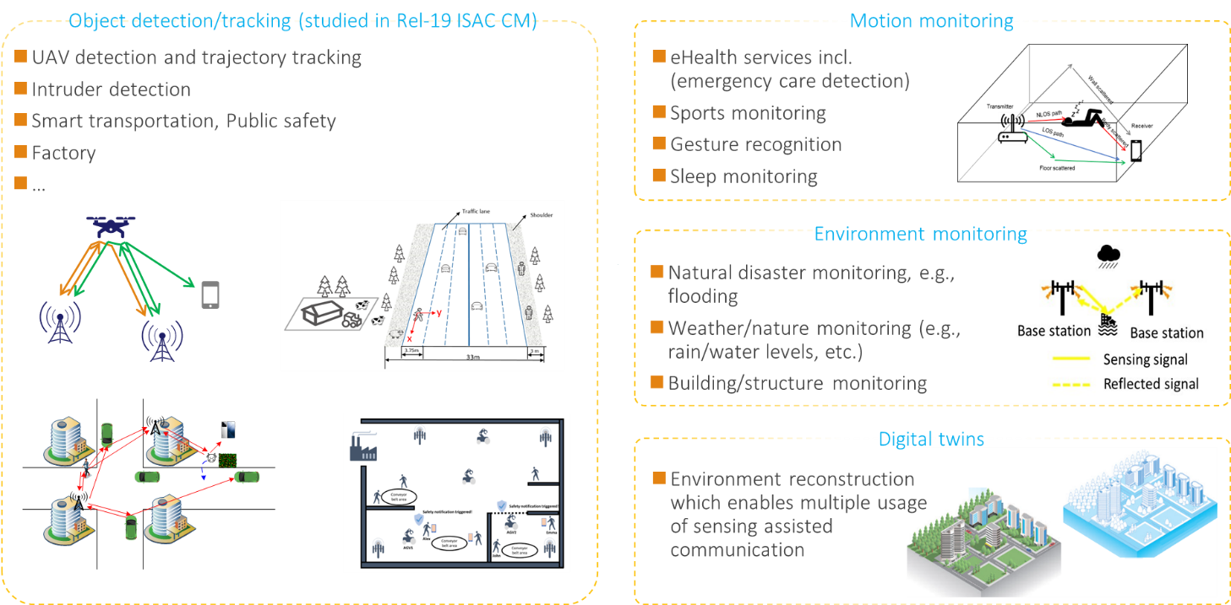
In previous RAN-P discussion, following agreements reached in RAN-P 6G study:
Agreement: (RP-252960, pCR to TR 38.914)
Editor note: More sensing use cases can be included depending on further discussion.
The 6GR and 6G RAN architecture shall at least support use cases of detection and/or tracking of passive objects, at least including UAVs, human, vehicles and AGVs.

Observation 1-1: According to 6GR RAN-P SI TR 38.914, at least support use cases of detection and/or tracking of passive objects, at least including UAVs, human, vehicles and AGVs. And other sensing use cases pending on further discussion.

ISAC in 5GA only considers TRP monostatic sensing for UAV use case. 6G Rel-20 is the first study item for an extensive study on ISAC in 3GPP system. And according to current SID, there is not any restriction or preference on the sensing mode. That is the following typical sensing modes can be considered in the 6G studies
- TRP monostatic
- TRP-TRP bistatic
- UE monostatic
- TRP-UE bistatic
- UE-TRP bistatic
- UE-UE bistatic (Uu based)
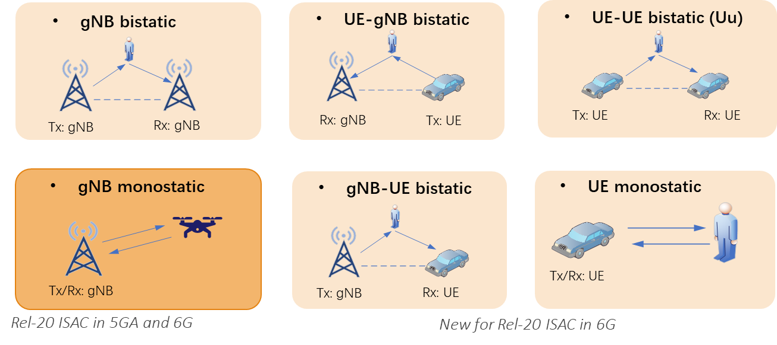

Observation 1-2: In 6GR, target use cases, sensing modes (e.g., mono-static, bi-static) and deployment scenarios are subject to RAN/SA and RAN1’s discussion and decision.

Since the sensing mode and other using scenarios still pending other WGs and RAN/SA decision, and the other fundamental physical layer design (e.g. the reference signal for sensing) are still subject to RAN1’s discussion. The earliest time for RAN1 discussion is Q2’ 26.
Thus, we shall wait other WGs’ progress to have discussion.

Observation 1-3: With sufficient progress from other WGs, it’s hard to have efficient discussion in RAN4 for ISAC
However, alternatively considering the limited time and lack of guideline from RAN plenary in the beginning of the SI, it is preferred to prioritize the basic scenario of ISAC for RAN4 study. For an example, RAN4 can start the discussion for TRP mono-static and TRP-UE bi-static sensing which are more general and without too high implementation complexity.

Proposal 1-1: RAN4 can start ISAC discussion from the typical sensing modes (e.g. TRP-TRP mono static sensing and TRP-UE bi-static sensing).

TRP- TRP Mono-static sensing | TRP- UE bi-static sensing

In the ITU‑R Radio Regulations, the radiolocation service is defined, the typical usage is radar. Based on this definition, a sensing system aligns more closely with the definition of a radiolocation service rather than IMT. In ITU-R IMT-2030 study ISAC is the one of the most important scenarios. The regulatory definition of the sensing service remains ambiguous.
One view is that sensing is used to assist communication services and therefore still falls within the scope of IMT services. The other view holds that if sensing provides services independently beyond IMT services, it should be categorized as a radiolocation service.
Nevertheless, there has been no discussion in ITU‑R regarding the service classification of sensing technology. However, national frequency study groups have already noticed this issue, as it involves revisions to national frequency regulations.

Considering regulatory issues, the UAV use case is the most sensitive in sensing systems, mainly due to the deployment distribution of UAVs. When a base station detects the position and velocity of UAVs, its detection beam may point above the horizontal level. This assumption is significantly different from the assumptions made when national regulators allocate spectrum for IMT systems.
Generally, when ITU-R and regional or national organizations allocate frequency bands for IMT and develop corresponding regulations, base station beams are normally not allowed to point above the horizontal level.
This is because:
- First, the coverage scenario of conventional base stations does not require beams above the horizontal;
- Second, if base station beams point above the horizontal, it may cause uncontrollable interference to existing services such as RAS and satellite services.
Therefore, even if the sensing system is part of the IMT system and reuses the existing frequency bands of IMT, it may still raise new regulatory issues and trigger corresponding updates to regulatory rules.
Observation 2: The regulatory issues related to sensing need to be noted and continuously tracked.

Conclusion
Observation 1-1: According to 6GR RAN-P SI TR 38.914, at least support use cases of detection and/or tracking of passive objects, at least including UAVs, human, vehicles and AGVs. And other sensing use cases pending on further discussion.
Observation 1-2: In 6GR, target use cases, sensing modes (e.g., mono-static, bi-static) and deployment scenarios are subject to RAN/SA and RAN1’s discussion and decision.
Observation 1-3: With sufficient progress from other WGs, it’s hard to have efficient discussion in RAN4 for ISAC
Proposal 1-1: RAN4 can start ISAC discussion from the typical sensing modes (e.g. TRP-TRP mono static sensing and TRP-UE bi-static sensing).
Observation 2: The regulatory issues related to sensing need to be noted and continuously tracked.

Reference
[1] TR38.765
[2] R4-2602151 Topic summary for [118][109] 6G sensing

